Smart Medical Report Generation Using Large Language Models

Abstract
Medical report generation is a critical, yet time-consuming task in modern healthcare systems. Manual creation of medical documentation often leads to inconsistencies, subjective interpretations, and an increased workload for medical professionals. This paper presents a smart medical report generator developed as part of a semester-long software engineering project.
The system is implemented using Spring Boot and integrates Large Language Models (LLMs) to automate clinical reasoning and report generation. By processing structured patient observations, medical history, and clinical indicators, the application produces consistent, structured, and reliable medical reports, demonstrating the practical benefits of AI-assisted automation in healthcare documentation.

1. Introduction and Problem Presentation
Medical reports play a crucial role in healthcare workflows, serving as a primary means of communication for medical professionals. These reports summarize patient conditions, observations, symptoms, and potential risks, supporting diagnostic and treatment decisions. Despite their importance, report creation is still frequently performed manually, which makes the process slow, repetitive, and prone to human error.
The motivation behind this project originates from the need to improve efficiency and consistency in medical documentation. Manual reporting not only consumes valuable time but can also result in inconsistent structure and terminology. The proposed system aims to automate medical report generation while preserving clinical relevance and structured output. This research component represents the final laboratory assignment and is directly based on the medical report generator developed during the project.

2. State of the Art
Traditional medical reporting systems are usually integrated into larger Electronic Medical Record (EMR) or Electronic Health Record (EHR) platforms. These systems typically rely on predefined templates and rule-based mechanisms, which ensure consistency but offer limited adaptability to complex clinical data.
Recent advances in Artificial Intelligence and Natural Language Processing have enabled new approaches to medical documentation. Large Language Models have demonstrated the ability to generate structured text, summarize clinical data, and support decision-making processes. Several studies highlight the potential of LLMs in automating clinical narratives and risk assessment, while emphasizing the importance of validation and reliability when deploying such systems in real-world environments.
Compared to purely template-based solutions, AI-assisted approaches provide enhanced flexibility and the ability to reason over heterogeneous medical data. However, integrating LLMs into enterprise-level backend applications remains challenging due to concerns related to data integrity, response validation, and system robustness.

3. System Architecture and Technologies
The smart medical report generator is implemented as a backend service using Spring Boot 3 and Java 21, following a layered architectural pattern. This design promotes separation of concerns and improves system maintainability and scalability.
The controller layer exposes RESTful endpoints responsible for receiving patient observations and triggering the report generation process. The service layer encapsulates the business logic and coordinates data processing, prompt construction, and AI interaction. An external LLM client communicates with the AI model using REST-based APIs.
The persistence layer uses Spring Data JPA and Hibernate to store generated reports, ensuring transactional consistency and version management. GSON is used for JSON serialization, while Lombok simplifies object construction through the builder pattern.
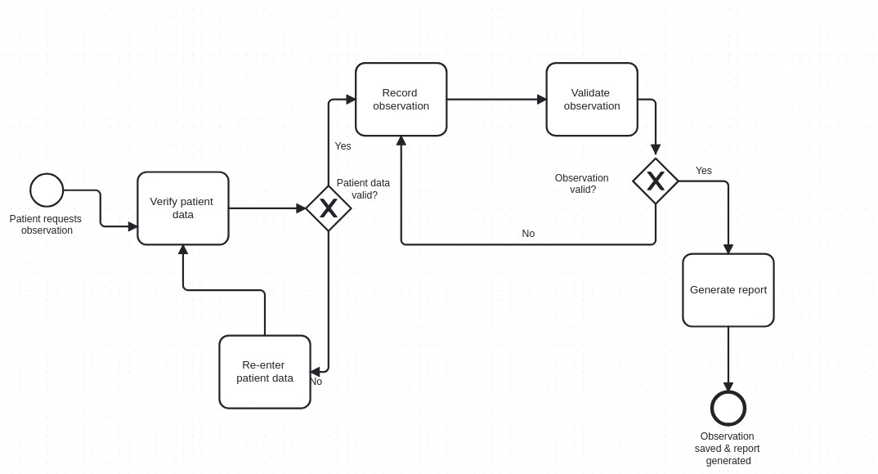

4. AI-Driven Medical Report Generation Pipeline
The core functionality of the application is implemented through a well-defined data processing pipeline.
- Data Extraction and Normalization: Patient demographics, vital signs, symptoms, and known risk factors are extracted from observations. Derived values such as age are computed automatically to enrich the dataset.
- Prompt Engineering: The system constructs a structured prompt optimized for the LLM, explicitly requesting a response in a predefined JSON schema. This approach ensures predictable and machine-readable output.
- AI Analysis and Validation: The LLM performs clinical reasoning based on the provided data and returns a structured analysis. The system validates the response for completeness and handles potential errors such as timeouts or malformed JSON.
- Persistence and Versioning: Validated reports are stored in the database, while older reports related to the same observation are automatically cleaned up to preserve consistency.

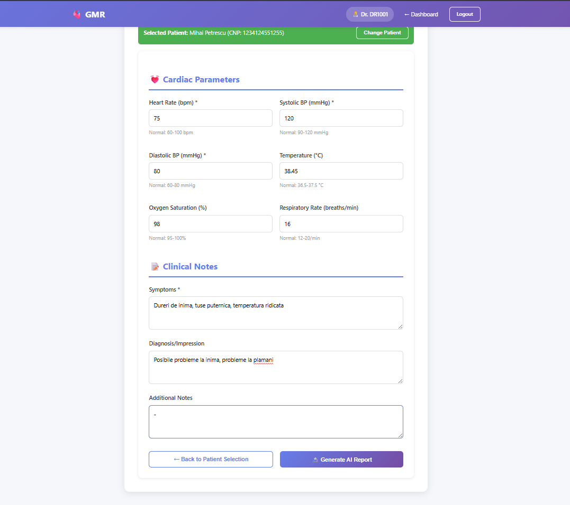
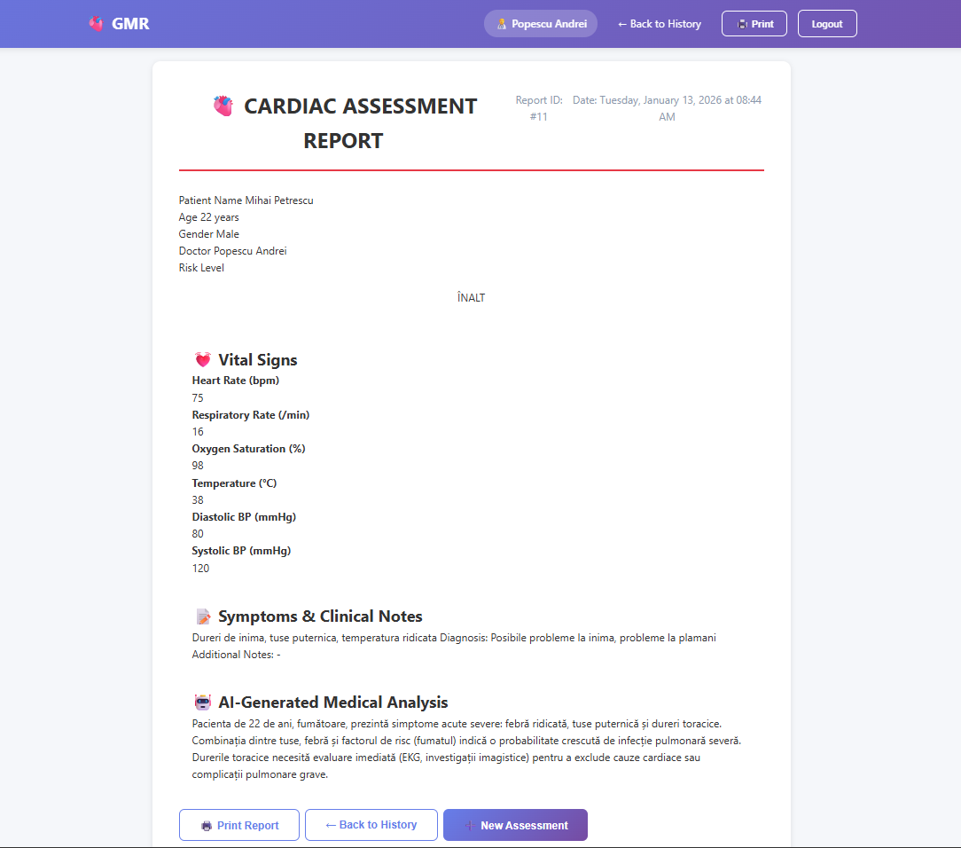

5. Results and Evaluation
The evaluation of the proposed system focuses on efficiency, consistency, and level of automation.
Compared to manual reporting, the application significantly reduces the time required to generate medical reports, producing structured output in a matter of seconds.
In addition to performance improvements, the system ensures standardized formatting and reduces the risk of human error. These results indicate that AI-assisted medical report generation can effectively support healthcare professionals, particularly in environments that require processing large volumes of clinical data.

6. Comparison with Other Approaches
When compared to traditional template-based reporting systems, the proposed solution offers greater flexibility and intelligent reasoning capabilities. Unlike manual workflows, it ensures consistent output and scalability.
Compared to existing EMR reporting tools, the system provides a transparent AI-driven analysis pipeline, making it easier to extend and adapt to future requirements.

7. Future Work
Potential future improvements include fine-tuning Large Language Models on domain-specific medical datasets, introducing multilingual report generation, adding explainable AI components, and integrating the system with real-world EHR platforms.

8. Conclusions
This paper presented a smart medical report generator developed using Spring Boot and Large Language Models. As the final laboratory project, it demonstrates the practical integration of AI-driven automation into real-world software systems, highlighting improvements in efficiency, consistency, and reliability in medical documentation workflows.

References
Spring Boot Documentation;
Research on Large Language Models in Healthcare;
AI-based Clinical Decision Support Systems;
Smart Medical Report Generator GitHub Repository : GitHub - davidfilimon/report-generator

